EXAMPLE
Plan for Fading Intervention Components
Westview Elementary School Excelsior Springs, Missouri

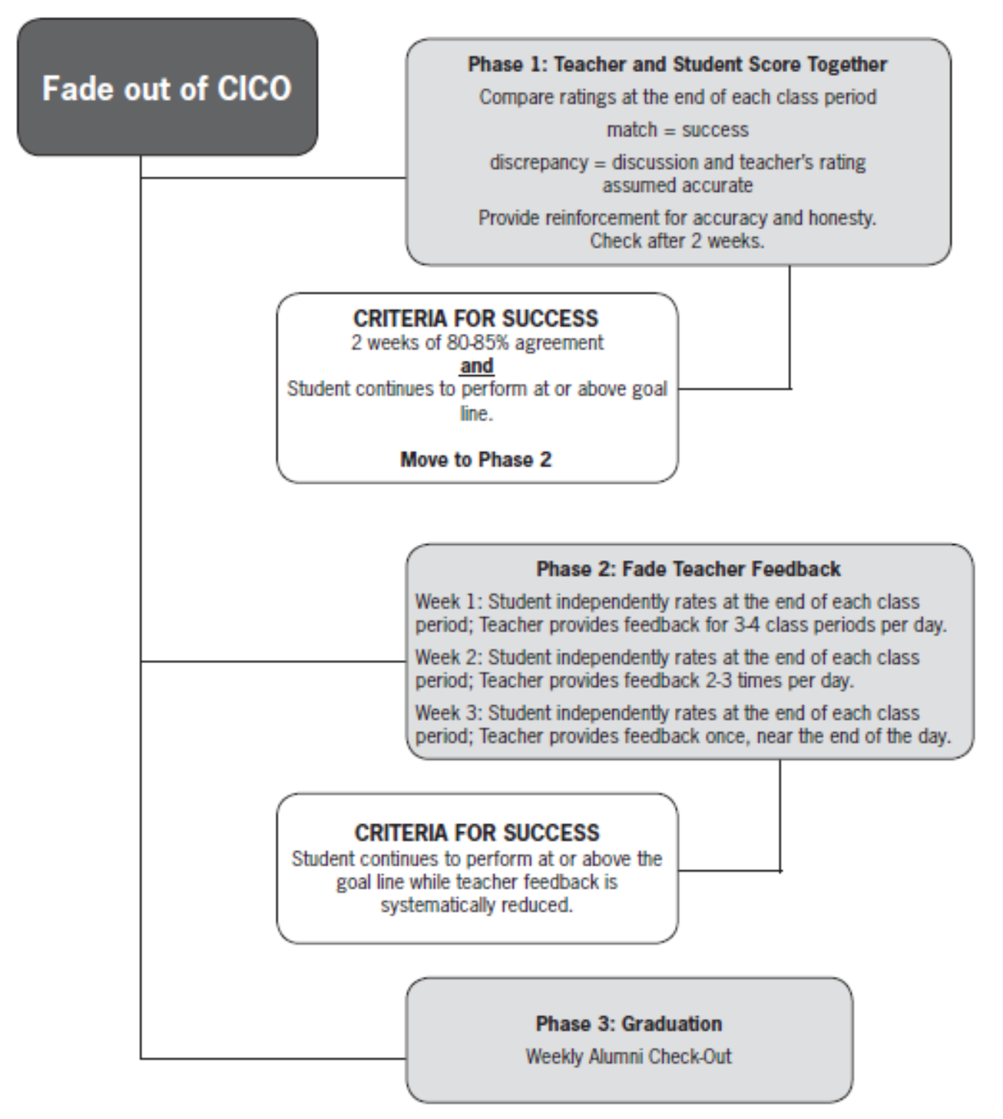

Check-In, Check-Out Fading Process
POST The following supports are available to CICO graduates if student requests or if teacher and/or GRADUATION Tier 2 committee determines the continued support would benefit the student:
▶ Student continues Check-In with interventionist at a determined frequency (daily, weekly); no CICO Form used and no Check-Out
▶ Student Check‐In daily with classroom teacher; no CICO Form and no Check-Out
▶ Student Check-In daily with classroom teacher; student scores independently on all time blocks on CICO Form with no teacher discussion and no Check-Out
Options for students receiving two behavior referrals after graduating CICO:
▶ Student returns to CICO and repeats only the Fade Process (but no graduation recognition)
▶ Student returns to full CICO
▶ Other support recommendations by Tier 2 committee
WEEK 3 Student scores independently on 5 of 7 time blocks on the CICO Form with no teacher discussion
▶ Continue as described in week 2.
WEEK 2 Student scores independently on 3 of 7 time blocks on the CICO Form with no teacher discussion
On remaining time blocks, proceed with teacher/student scoring together as performed in week 1
Teacher provide reinforcement for accuracy and honesty
▶ If student data remains at behavior goal of 80% or higher and student/teacher ratings agree at least 80% of time, proceed to next week instructions. If not, perform this week again.
WEEK *1 Teacher and student score together and compare ratings at the end of each class period
match = success OR discrepancy = discussion with teacher’s rating assumed accurate
Teacher provide reinforcement for accuracy and honesty
▶ If student data remains at behavior goal of 80% or higher and student/teacher ratings agree at least 80% of time, proceed to week 2. If not, perform week 1 again.
WEEK 4 Student scores independently on ALL time blocks on the CICO Form with no teacher discussion
▶ If student data remains at behavior goal of 80% or higher, student is ready to graduate from CICO. Student will continue to Check In each morning with interventionist until date of graduation or other date as determined by Tier 2 committee and teacher. Student will no longer utilize the CICO Form, unless requested by student.
*A week equals at least 4 days

