Effective principals manage the management so principals do the instructional work necessary to move teaching practice forward.

Introduction and Rationale:

Research shows that principals can make a dramatic difference in student performance if their focus is on working with teachers to improve practice. Most leaders fall into a trap where their focus becomes school management. The culture in many schools supports a principal as manager rather than instructional leader.
In 2003 the Wallace Foundation funded the SAM® process to determine if leaders could create structures and culture where they could spend the majority of their time on instructional work rather than management. Ten years of research resulted in a surprising answer: Yes, and the success of a principal is not limited by staffing, social economic factors or school size.
Additionally, these principals worked a shorter day and expressed a higher level of job satisfaction. The research is clear: principals can spend the majority of their time working to improve teaching and learning (PSA, 2011, Vanderbilt, 2015).
Stephen R. Covey, in his bestselling book 7 Habits of Highly Effective People, illustrates the school leader’s dilemma through what he calls the time management matrix. In Covey’s illustration, leaders are encouraged not to mistake urgency for importance in daily tasks, but rather to focus on the things that are not urgent, yet important. (Covey, 1989)

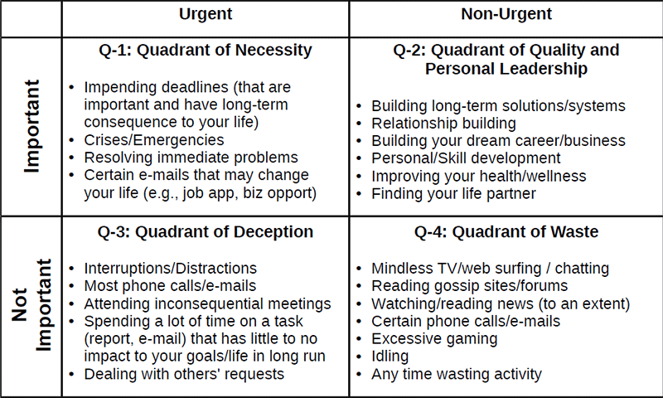

School leadership is second only to teaching among school-related factors in its impact on student learning. (Leithwood, 2004) High quality school leadership is an important factor in attracting and retaining high quality teachers (Mitgang, 2008). Once employed, high quality teachers are more engaged and productive when administrators focus on instructional capacity building and the moral implications of excellent instruction (Fullen, Cuttress & Kilcher, 2005).
Teacher working conditions, in schools where administrators are highly engaged in instructional leadership, are reported as more positive, professional, collegial, and productive (Wahlstrom, Louis, Leithwood, & Anderson, 2010).

