Missouri Model Districts
Technology Request Forms

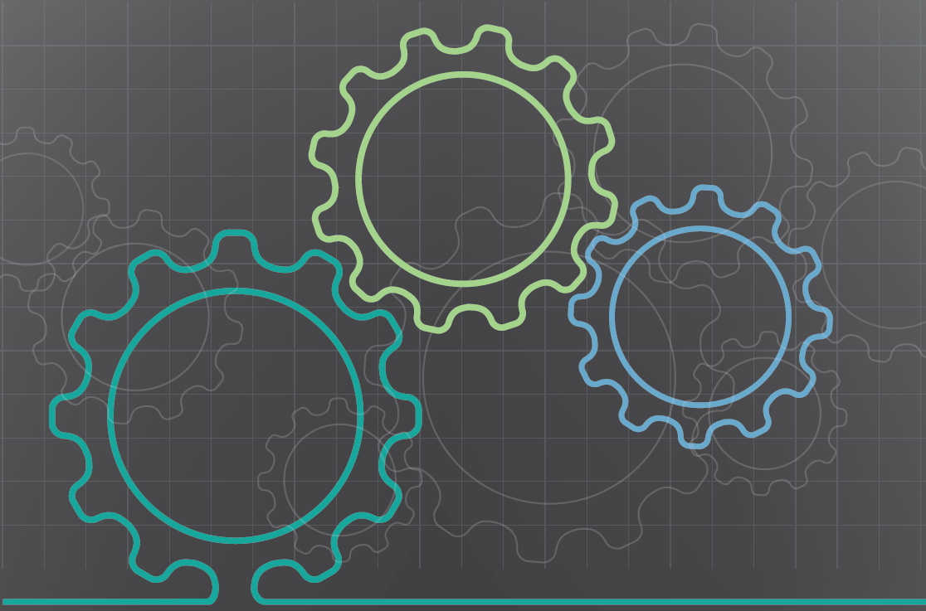

December 2018

Goal of MMD
Using a district-level approach, the goal of Missouri Model Districts (MMD) is to integrate effective academic and behavioral practices into a framework for achieving exceptional student outcomes.

Role of Technology
Technology can support and enhance implementation of MMD goals by increasing access to timely training and coaching relevant to the district/building context, broadening opportunities for collaborative professional learning, and strengthening district/building-based professional development support. To reach this vision of using technology, five key functions of technology will be supported in districts.
- Communication and collaboration
- Sharing resources and information
- Professional learning
- Coaching
- Data-driven reflection and problem-solving
To support access to MMD-related web-based resources as well as address key functions of communication and collaboration and coaching, districts will have the opportunity to review current technology resources and uses, identify gaps, and receive tools and guidance.

Commitment to Sharing
There is an expected commitment to share information about how your technology is being used. This sharing should include information about the tools used, how they were used to accomplish the Missouri Model District goals, and an evaluation of their benefit based on progress towards those goals.

Funding
Districts can apply for technology funding twice during their MMD commitment. One request should focus on MMD-based communication at the district level. The second request should focus on communication and collaboration at the building level. Requested technology must advance the goals defined in the table below. To be considered for funding, complete the Technology Support Request Form and submit it by email to your MMD CST Facilitator.

The MMD statewide tech team can provide suggestions on possible tools and help completing this form. Please use the following link to provide information, and the MMD tech team will follow up with you. bit.ly/mmdtechreq

District Communication Funds: Focus on communication  $1,000 per district across the three-year commitment  District Communication Goals  - Increase the use of technology for effective communication among district leadership team, Coaching Support Team, and DESE.  - Increase access to web-based MMD tools and resources.  DESE Communication Goals  - Receive district feedback on the use of provided technologies for effective communication and collaboration and revise support strategy, as needed.  - Receive and address district feedback for improving web-based tools and resources. | Building Collaboration Funds: Focus on communication and collaboration  $500 per building across the three-year commitment  Building Collaboration Goals  - Increase the use of technology for effective communication/collaboration within buildings, and among district leadership team, Coaching Support Team, and DESE.  - Increase access to web-based MMD tools and resources.  DESE Collaboration Goal  - Receive district feedback on the use of provided technologies for effective communication and collaboration and revise support strategy, as needed.

District Technology Request Form

District: Focus on communication
District:

District Contact (name, email, phone):

Activity:  - Conduct virtual meetings between District Leadership and the Coaching Support Team  - Conduct virtual meetings between District Leadership and the Building Teams  - Conduct virtual meetings between multiple Building Teams  - Conduct virtual meetings between multiple District Leadership Teams  - Other | This activity could include multiple variations within a given virtual setting:  - One person to one person  - One person to small group  - Small group to small group (note: small groups may be in one or multiple locations)  - Screen sharing  - Document sharing, collaboration, and editing  - Shared drive/file storage
Action Plan
How will the requested tool(s) advance implementation of District Goals?

Who will be responsible for implementation of the activity?

What is the projected timeline for implementation?

How will the benefit of the tools be evaluated based on progress towards the stated goals, including any remaining gaps?

How will results of the evaluation be shared?

How will access and use of the equipment be monitored?

Suggested list of tools: Video conferencing app, webcam, speakerphone, extension microphone, projector, projector screen, file sharing, and collaboration apps (e.g.: google apps and drive).

The MMD statewide tech team can provide suggestions on possible tools and help completing this form. Please use the following link to provide information, and the MMD tech team will follow up with you. bit.ly/mmdtechreq

Requested Tools: (Select tools from the suggested list above. Once a specific tool has been selected, identify it by its advertised brand name.) | Cost: (List the cost for each tool selected.)
 | Total Costs
District Contact Signature |  | Date
District Step 1: After obtaining district signature, submit form by email to your MMD CST Facilitator. If no follow up is required, it will be sent to DESE for funding consideration.
MMD CST Facilitator Signature |  | Date
- Consulted with Statewide Tech Team
DESE Approval Signature |  | Date

District Step 2: After notification of funding approval, submit an invoice for reimbursement on district letterhead with attached copy of receipts for tech purchases. Submit invoice by email to: DESE.GrantInvoices@dese.mo.gov.

Building Technology Request Form

Building: Focus on communication and collaboration
District:

District Contact (name, email, phone):

Building:

Building Contact (name, email, phone):

Activity:  - Conduct virtual meetings between external and school-based coaches  - Conduct virtual meetings between school-based coach and teacher  - Record a classroom session for observation by school-based coaches/teams  - Share recorded sessions for observation by school-based coaches/teams  - Other | Recording and sharing classroom sessions could include:  - Recording and/or remote viewing of a classroom session  - Uploading recorded session to a shared drive  - Sharing recorded sessions
Action Plan
How will the requested tool(s) advance implementation of Building Goals?

Who will be responsible for implementation of the activity?

What is the projected timeline for implementation?

How will the benefit of the tools be evaluated based on progress towards the stated goals, including remaining gaps?

How will results of the evaluation be shared?

How will access and use of the equipment be monitored?

Suggested list of tools: Video conferencing app (basic free or advanced subscription), webcam, speakerphone, extension microphone, projector, projector screen, wifi expansion (routers, cabling, etc.), file sharing, and collaboration apps (e.g.: google apps and drive), video and audio recording equipment.

The MMD statewide tech team can provide suggestions on possible tools and help completing this form. Please use the following link to provide information, and the MMD tech team will follow up with you. bit.ly/mmdtechreq

Requested Tools: (Select tools from the suggested list above. Once a specific tool has been selected, identify it by its advertised brand name.) | Cost: (List the cost for each tool selected.)
 | Total Costs
District Contact Signature |  | Date
District Step 1: After obtaining district signature, submit form by email to your MMD CST Facilitator. If no follow up is required, it will be sent to DESE for funding consideration.
MMD CST Facilitator Signature |  | Date
- Consulted with Statewide Tech Team
DESE Approval Signature |  | Date

District Step 2: After notification of funding approval, submit an invoice for reimbursement on district letterhead with attached copy of receipts for tech purchases. Submit invoice by email to: DESE.GrantInvoices@dese.mo.gov.

