Wonderful Preschool Example

Student Name ______________________ Date ________________

Goal:

Goal Reached: Yes No

Goals | Centers | Circle Time | Table Time | Snack Time | Large Motor Play
Use walking feet

Use nice words
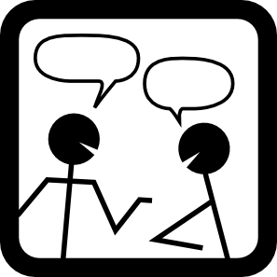

Use listening ears
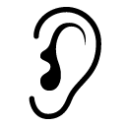

Parent/Guardian Signature ___________________________

I’m proud of you today because:

