Effective principals work to build trust personally and throughout the organization.
EXERCISE: It is unusual for a person to be naturally and equally strong in all four of these areas. It is more likely that each administrator will exhibit strength in one or two elements and recognize the need for development in the others.
  - Do a personal self-assessment of the four elements of trust by reflecting on the brief descriptions and scoring oneself on a five-point scale.
  - Extend your reflection and learning by engaging with mentors, coaches, and colleagues in person and online.
Self Assess
Work to improve in your low areas
Apply the findings to the whole school level

EXERCISE: On a piece of paper divide the space (T-chart style) into two categories: personal and organizational. Reflect on the four elements of trust. Provide examples of how strong the trust is both personally and organizationally.

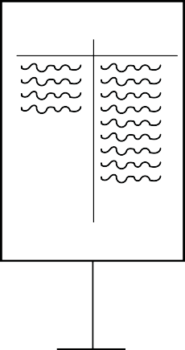
Acceptance
Personal Organizational
Reliability
Personal Organizational
Openess
Personal Organizational
Congruence
Personal Organizational

