Self-Reflection Opportunities & Indicator Systems
Tips from Connie Moss to encourage student self –reflection
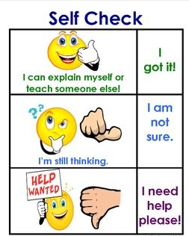

For learning targets involving concepts, indicator systems can be used for self-reflection. Here’s an example of nonverbal signals students can give as they self-reflect. Rather than asking, “How many of you understand?” ask, “How well do you understand?” Students can use indicator systems, such as color-coded papers: Green - I understand; Yellow – I’m not sure about some parts; Red – Much is difficult and I don’t know what to do to make it better.

Other Self-Assessment Opportunities

Start small and continue to build in self-assessment opportunities.

Pause & Think – Assess work by taking a few minutes to pause/think/reflect on learning
Look for Proof- Select work sample or part of their work as proof & comment about it.
Connect to Criteria – Students assess their work in relation to criteria & find evidence to show they have met criteria.

Adapted from: Learning Targets: Helping Students Aim for Understanding in Today’s Lesson by Connie Moss.

