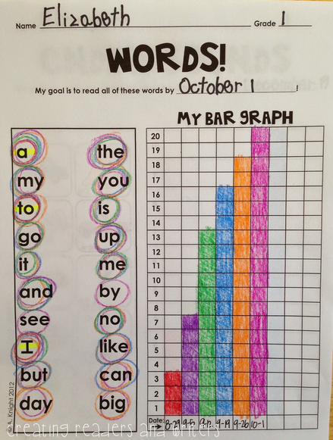
Students work in pairs to assess sight words by circling words known. Bar graphs are created using a different color each time word recognition is assessed. Bars represent number of words recognized at each assessment.

