Example
Missouri Middle School
SW-PBS Leadership Team

In collaboration with staff and students, the Schoolwide SW-PBS Team provides leadership for the development, implementation, and maintenance of procedures that promote responsible student behavior and a positive learning environment in our school.

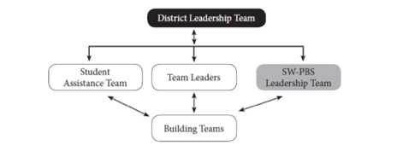

Team Composition
- Building Administrator
- Guidance Counselor
- Sixth Grade Teacher
- Seventh Grade Teacher
- Eighth Grade Teacher
- Special Education Teacher
- Paraeducator
- 3 Students
- 3 Parents

