Instructions: Based on how you interpret the steps for the respective protocols, draw a line from the questions on the right to the step that addresses it in the protocol on the left.
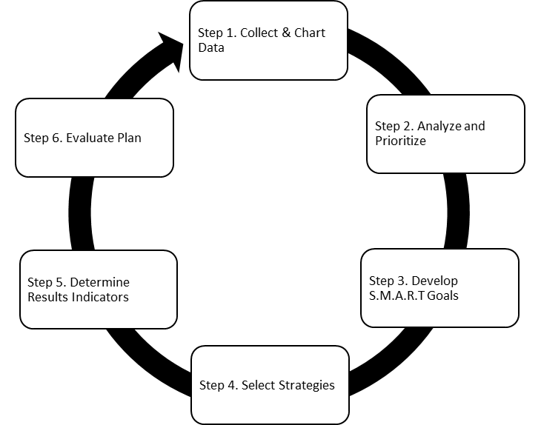
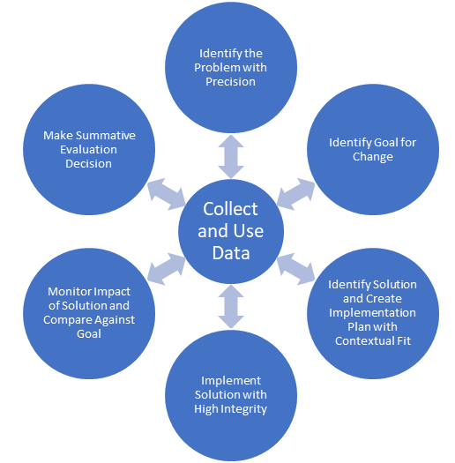
National Center on PBIS T.I.P.S.
Leadership and Learning Data Teams
MO SW-PBS Decision Making Model
Questions
- Is there a problem?

- Why is there a problem?

- What can be done about the problem?
- Did the plan work?
Questions
- Is there a problem?

- Why is there a problem?

- What can be done about the problem?
- Did the plan work?
Questions
- Is there a problem?

- Why is there a problem?

- What can be done about the problem?
- Did the plan work?
Instructions: For this page, match the Essential Function to the corresponding question that all good DBDM protocols must answer.

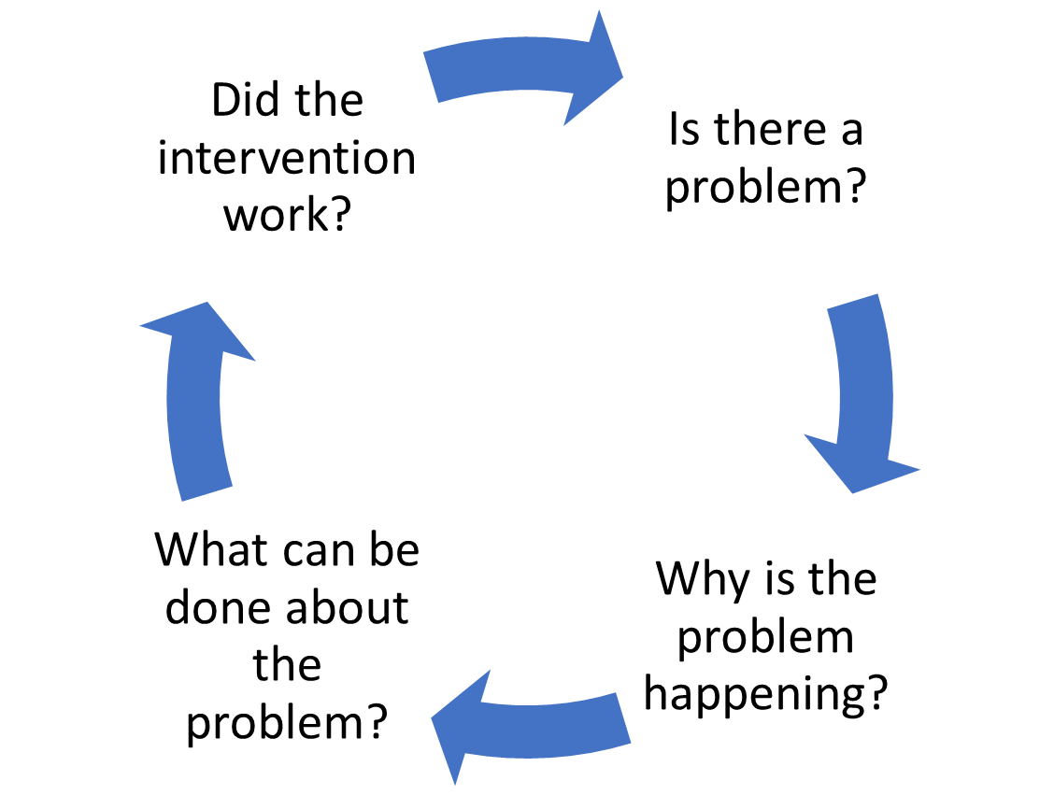
Tilly, 2010
Essential Functions
- Educators establish collaborative process for collecting data.

- Educators implement a process for examining and interpreting data.

- Educators determine action steps.

- Educators use implementation and student outcome data to determine next steps.

