User Manager Virtual Learning Platform (VLP) Checklist
Contents
A. Manually Grant Access to District and Building Administrators: 1
B. Hierarchical Security Roles: 2
C. Educators without a Web Application Account: 3
D. Educators with a Web Application Account that Isn’t Linked to Educator Certification Profile 3
E. 2020-21 MOSIS October Cycle Educator Files 3
F. FYI: VLP Access Questions 3
G. Reminder: Assurance Agreement 3
H. Reminder: User Manager Application Tutorial 3

Manually Grant Access to District and Building Administrators:
User Managers must manually grant access to district administrators and building administrators.

To grant access to the district administrators:
- Select the VLP application at the district level.
- Select the Virtual Learning Platform District Administrator checkbox.
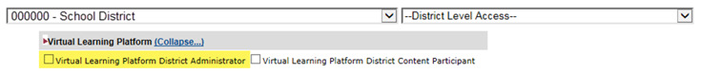
- Click the Process Access Request button.

To grant access to the building administrators:
- Select the administrator’s building from the District Level Access dropdown to open VLP application at the building level.
- Select the Virtual Learning Platform District Building Administrator checkbox.
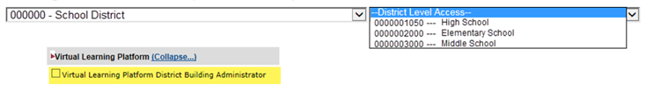
- Click the Process Access Request button.

Hierarchical Security Roles:
VLP security roles are setup in a hierarchical structure. Each ascending security role has more access than the level below it. Ex. An account with the Professional Development Coordinator security role can perform the same actions as accounts with Building Administrator or District Content Participant.
What does this mean for you?
You should look at the level of access needed for each account and select the highest level of access required.
Here are a few scenarios for your consideration:
- When granting access to new accounts or existing accounts without VLP access, select the highest, relevant level of access requested for the account.
- When granting a higher level of access to existing accounts with VLP access, deselect the existing security role and select the desired level of access.
- When granting a lower level of access to existing accounts with VLP access, deselect the existing security role and select the desired level of access.

VLP Security Role Hierarchy:

Level | Role Title | Who should get access? | What can the user do in VLP?
Level 1 | District Administrator | Superintendents, Assistant Superintendents | - Create assignments for assessments and professional learning modules (PLM) for the entire district,  - Complete and view observations for district staff  - District Needs Assessments
Level 2 | Professional Development Coordinator | Curriculum & Instruction, Special Education Director | - Create assignments for assessments and professional learning modules (PLM) for the entire district,  - Complete and view observations for district staff
Level 3 | Building Administrator | Principals, Assistant Principals, etc. | - Create assignments for assessments and PLM for that building,  - Complete and view observations for building staff
Level 4 | District Content Participant | Counselors, Librarians, Paras, Teachers, etc. | - Enroll and complete PLMs and assessments

Educators without a Web Application Account:
If you identify an educator without a web applications user ID, it means they either
- have not created an account; or
- had an idle account, which has been removed.
These educators will need to create a new account on the DESE Secured Web Application Logon site.
Instructions for Registering for a DESE Web Application can be viewed directly on the DESE Secured Web Application Logon page or DESE’s YouTube page.

Educators with a Web Application Account that Isn’t Linked to Educator Certification Profile
If your educator has a web applications account that is not linked to their educator certification profile, their account will not be automatically granted access to the VLP. See step-by-step Instructions to link to Ed Cert profile in the PDF attached to the original email or within VLP for more details.

2020-21 MOSIS October Cycle Educator Files
The automatic process to grant user participant access to VLP utilizes the 20-21 MOSIS educator data; therefore, any users added by the process represents current 20-21 staff. Participant access will be granted once the district certifies the MOSIS October Cycle Educator files. The information pulled for VLP includes educators’
- current district;
- current building; and
- position code.

FYI: VLP Access Questions
For additional assistance with granting VLP access, please refer to the VLP Adding Users tutorial located on DESE’s YouTube page or email with additional questions.

Reminder: Assurance Agreement
To ensure that each district user has the correct access to DESE’s web applications, one of your district’s user managers must review and agree to the assurance agreement at the beginning of each school year. More information on assurance agreements will come out at the beginning of August.
As a reminder, adding all educators to the VLP application will increase the amount of time it takes to review the 2020-21 assurance agreement.

Reminder: User Manager Application Tutorial
Whether you are new to using User Manager or a seasoned veteran, you can view the User Manager Webinar found on DESE’s YouTube page, which shows district user managers how to navigate the application (i.e., grant access, verify the assurance agreement, search for users to add to your district and more).

