Next Steps: Actions = Results Leadership for Effective Implementation of District-Wide Evidence Based Practices
Focus: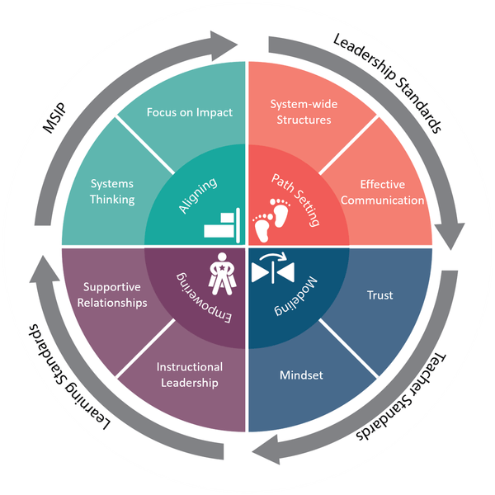
☐Aligning ☐Path Setting ☐Modeling ☐Empowering

District/School: _________________________ Date Next Steps Form Written:______________________________

Leadership Team: _________________________________________________________________________________

Action Planned  What? | Responsible Person(s)  Who? | Timeline  When? | Resources/Support Needed | Results  So What?

