Next Steps-Planning Template: Whole Learning Target
Learning Standard (Write and unwrap.)
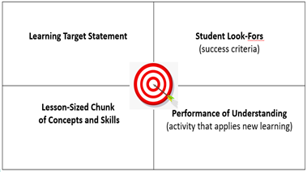
Academic vocabulary

Learning Targets | DOK | Success Criteria | Instruction & Learning Activity  (closely aligned with learning target) | Formative Assessment
Adapted from:
Nielson, M. (2016, July 19). Unpacking standards leads to confidence, not chaos for teachers and students. All Things Assessment. [Blog]. Retrieved from https://allthingsassessment.info/2016/07/19/unpacking-standards-leads-to-confidence-not-chaos-for-teachers-and-students/
Moss, C., Brookhart, S. (2019). Advancing formative assessment in every classroom: A guide for instructional leaders. ASCD.

